This folder contains the training dataset that will be used in the 2026 Machine Learning Final Project/ Poster Competition. We have provided you with 4 percussion-induced audio datasets collected from 4 pairs of bolted flanges in a pipeline system (Fig. 1), respectively. These datasets were conducted by hitting the surface of flanges with a steel hammer and recorded by an iphone (48kHz sampling rate). The flat side of the hammer was used rather than the ball peen side to limit damage to the flange surface (Fig.2). Three looseness/tightness levels (0, 25, 50 ft-lbs) are considered, and the four bolts and nuts of a pair of flange are tightened in the same preload level. In Table 1, each dataset has around 80 samples per class (0/25/50 ft-lbs), resulting in around 240 samples in total. Within a batch of 80 (20x4) samples, every 20 samples are from an area (marked in Fig. 3).

Table1. Datasets Arrangement.
Flange ID | Dataset ID | Number of signal-hit percussion-induced audio signals in a preload level |  |  | Total number of samples in a set
 |  | 0 ft-lbs | 25 ft-lbs | 50 ft-lbs
1 | 1 | 80 | 80 | 80 | 240
2 | 2 | 80 | 80 | 80 | 240
3 | 3 | 80 | 80 | 80 | 240
4 | 4 | 80 | 80 | 80 | 240
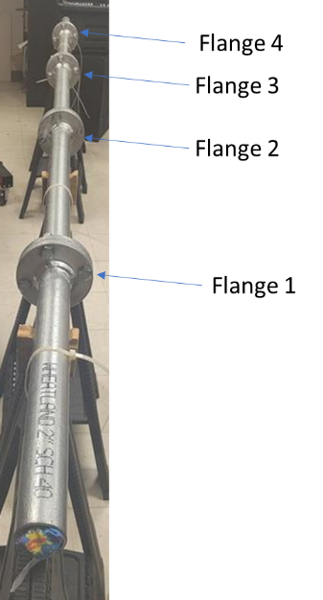
Fig. 1. A pipeline system with four bolted flanges
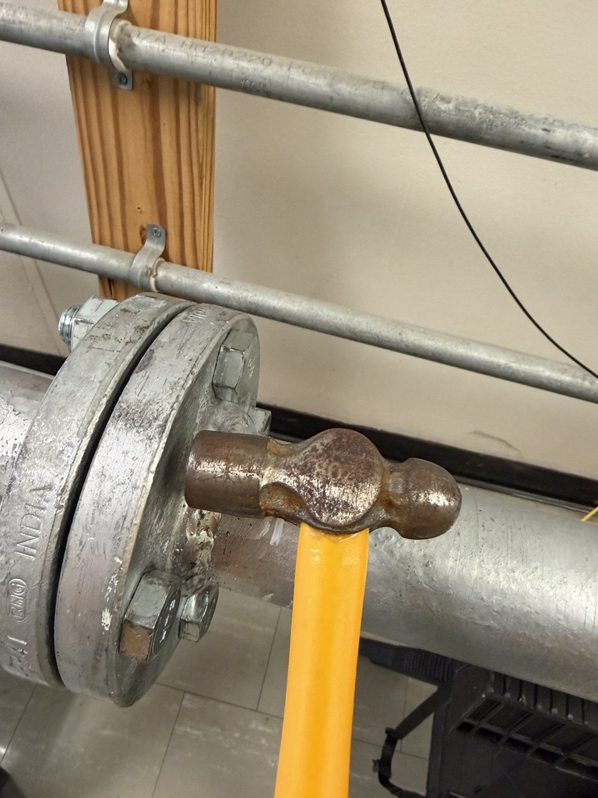
Fig. 2. A hammer hitting the flange.

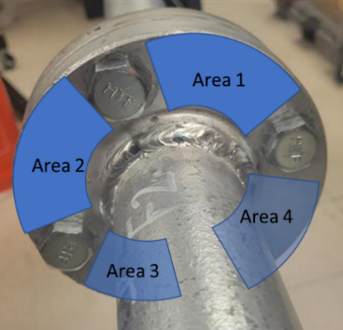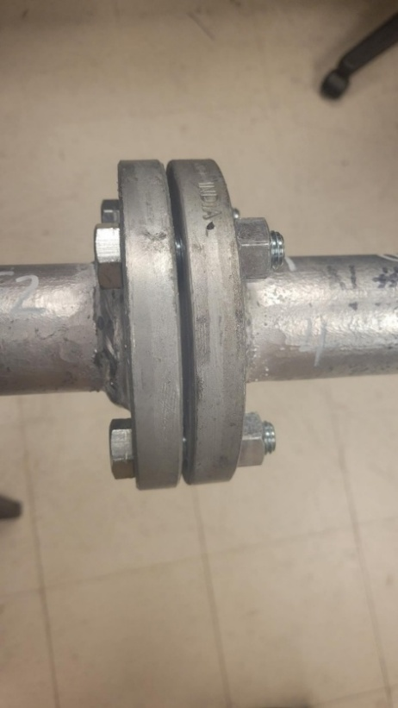
Fig. 3. A pair of bolted flange (front view and side view)

